**Program 01 :** To print if a number is a multiple of 3

isMultOf3 = function(num) {

if((num %% 3) == 0) {

print(paste("Number is a multiple of 3 !"));

} else {

print(paste("Number is not a multiple of 3 !"))

}

}

num = readline("Enter a number : ");

num = as.integer(num);

isMultOf3(num)

**OUTPUT :**



**Program 02 :** To find minimum of 3 numbers

min = function(num1, num2, num3) {

if(num1 < num2) {

if(num1 < num3) { print(paste("Number 1 smallest ! : ", num1)); }

else { print(paste("Number 3 smallest ! : ", num3)); }

}

else {

if(num2 < num3) { print(paste("Number 2 smallest ! : ", num2)); }

else { print(paste("Number 3 smallest ! : ", num3)); }

}

}

num1 = readline("Enter 1st number : ");

num1 = as.integer(num1);

num2 = readline("Enter 2nd number : ");

num2 = as.integer(num2);

num3 = readline("Enter 3rd number : ");

num3 = as.integer(num3);

min(num1, num2, num3)

**OUTPUT :**

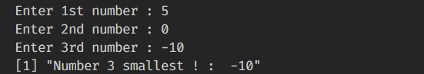

**Program 03 :** To implement calculator using switch statements

calculator = function(val1, val2, op) {

result = switch (

op,

"A"= cat("Addition = ", val1 + val2),

"D"= cat("Subtraction = ", val1 - val2),

"R"= cat("Division = ", val1 / val2),

"S"= cat("Multiplication = ", val1 * val2),

"M"= cat("Modulus = ", val1 %% val2),

)

print(result);

}

print(paste("A <- Addition"))

print(paste("D <- Subtraction"))

print(paste("R <- Division"))

print(paste("S <- Addition"))

print(paste("M <- Modulus"))

num1 = readline("Enter 1st number : ");

num1 = as.integer(num1);

num2 = readline("Enter 2nd number : ");

num2 = as.integer(num2);

op = readline("Enter operator : ");

calculator(num1, num2, op)

**OUTPUT :** 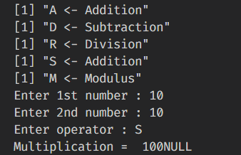

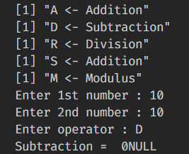

**Program 04 :** To read and determing if a character is a vowel or consonent

checkChar = function(ch) {

if (ch=='a' || ch=='e' || ch=='i' || ch=='o' || ch=='u' || ch=='A' || ch=='E' || ch=='I' || ch=='O' || ch=='U') {

print(paste("Character is a vowel !"));

} else {

print(paste("Character is a consonant !"));

}

}

ch = readline("Enter a character : ");

ch = as.character(ch);

checkChar(ch)

**OUTPUT :**





**Program 05 :** To create a vector and determine if each element is even or odd

is_even_odd = function(x) {

if (x %% 2 == 0) {

print(paste(x, ": Even"))

} else {

print(paste(x, ": Odd"))

}

}

n = readline("Enter no. of entries : ");

numbers = c();

print(paste("Enter ", n," numbers : "))

for(i in 1:n) {

num = readline();

num = as.numeric(num);

numbers = append(numbers, num);

}

cat("Vector:", numbers, "\n")

for(i in 1:length(numbers)) {

is_even_odd(numbers[i])

}

**OUTPUT :**

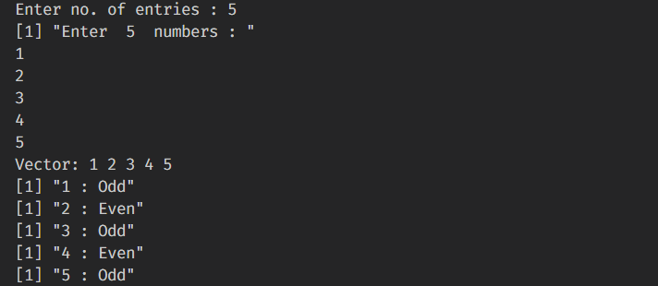

**Program 06 :** To implement functions to calculate area of circle, rectangle and square

circle_area = function(radius) {

return(3.14 * radius^2)

}

rectangle_area = function(length, width) {

return(length * width)

}

square_area = function(side) {

return(side^2)

}

radius <- 5

length <- 4

width <- 6

side <- 3

circle_result <- circle_area(radius)

rectangle_result <- rectangle_area(length, width)

square_result <- square_area(side)

cat("Area of the circle with radius", radius, "is", circle_result, "\n")

cat("Area of the rectangle with length", length, "and width", width, "is", rectangle_result, "\n")

cat("Area of the square with side", side, "is", square_result, "\n")

**OUTPUT :**

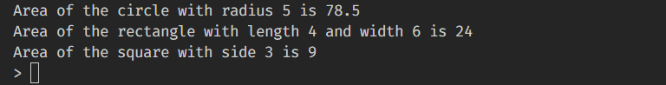

**Program 07 :** To implement functions to read student marks and return grade

computeGrade = function(marks) {

sum = 0;

for(i in 1:length(marks)) {

sum = sum + marks[i];

}

percentage = sum / length(marks);

if(percentage >= 80 && percentage <= 100) { print(paste("Secured A+ Grade")); }

else if(percentage >= 61 && percentage <= 79) { print(paste("Secured A Grade")); }

else if(percentage >= 51 && percentage <= 60) { print(paste("Secured B Grade")); }

else if(percentage >= 40 && percentage <= 50) { print(paste("Secured C Grade")); }

else if(percentage < 40) { print(paste("Secured F Grade")); }

}

n = readline("Enter no. of subjects : ");

marks = c();

for(i in 1:n) {

num = readline();

num = as.numeric(num);

marks = append(marks, num);

}

computeGrade(marks);

**OUTPUT :**

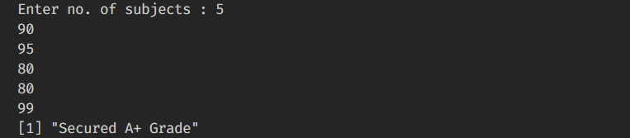

**Program 08 :** To find min and max of no.s stored in a vector

min_max = function(numbers) {

min = numbers[1];

max = numbers[1];

for(i in 1:length(numbers)) {

if(numbers[i] < min) { min = numbers[i]; }

if(numbers[i] > max) { max = numbers[i]; }

}

print(paste("Max : ", max));

print(paste("Min : ", min));

}

numbers = c(12, 5, 8, 20, 3, 15, 7);

min_max(numbers);

**OUTPUT :**

